**Proof:**

We can see in the below figure that on turn 54 the player Fred had a balance of 10, then on turn 55 he bet on Crown which was rolled, however his balance is still set at 10.

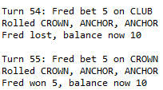

**Hypothesis:** There are a number of different areas where the bug could be occurring, Appropriate Junit tests / Debug Proof will be setup to test each one.

|  |  |  |
| --- | --- | --- |
| Theory | Junit Test / Debug Proof | Result |
| The players balance is not being set correctly |  |  |
| The receiveWinnings method is not functioning correctly |  |  |
| The playRound method is not functioning correctly |  |  |
| The value being set in bet for some reason is 0 when applied to the player |  |  |
| All methods could be working correctly however the output of the information to the screen could be incorrect |  |  |